**Programming for problem solving II**

**Assignment 8 –Graphs**

1. Given a undirected Graph of N vertices: 1 to N, and M edges, consider the representation of the input graph (given next) such that that there is an edge between vertex X and vertex Y, the task is to write a C program to create Adjacency List of the given Graph:

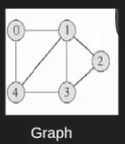

1. Given a undirected Graph of N vertices: 1 to N, and M edges, consider the representation of the input graph such that that there is an edge between vertex X and vertex Y, the task is to write a C program to create Adjacency Matrix of the given Graph.

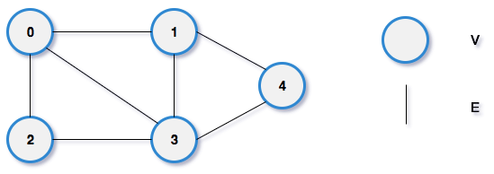

1. C program to show the bfs traversal of the graph

Input is: 5 vertices (starting vertex is marked as 0)

Take graph data in matrix form as follows:

**0 1 0 0 1  
1 0 1 1 1  
0 1 0 1 0  
0 1 1 0 1  
1 1 0 1 0**

1. C program to show the dfs traversal of the graph. (Note: Use the same input as bfs traversal to see the difference)